Skills Workshop # 4: Wiki Creation
Speaker: Denny Dupps and Jack Broering
Date: Monday, June 19, 2017
Time: 10:30 – 11:30 AM
Venue: University of Cincinnati, Swift Hall, room 516
Prepared by:
John McClellan, Reading Community High, Reading, Ohio
RET Participants for Project #3: “Bio-inspired Optimization for the Traveling Salesman Problem”
This session was given by Denny Dupps and Jack Broering on Monday, June 19, 2017 from 10:30 – 11:30 AM at the University of Cincinnati in Swift Hall, room 516. Denny Dupps has a background of technological expertise, working at Indian Hill School District for the past 48 years. He is a self-proclaimed “old-timer” who suggests that everyone be willing to change. Before his lecture began, he had RET participants make a copy of his Wiki workshop files to use during the presentation.
Denny Dubbs started the presentation by outlining the objectives of the session, namely, to know what a “Wiki” is, to understand the need, and the creation of a personal wiki. This outline, see Figure 1, was displayed slide-by-slide in a PowerPoint. After outlining the objectives, Dubbs moved forward to explain why a Wiki is a helpful tool: it acts as an online website, making it very easy to collaborate with fellow teachers, and allowing the owner to control who gets to see their material.
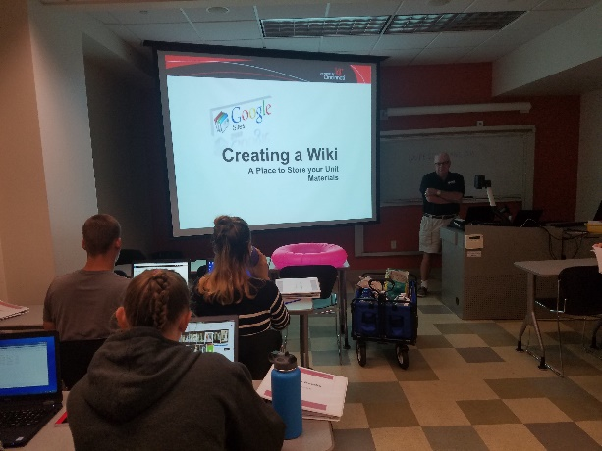
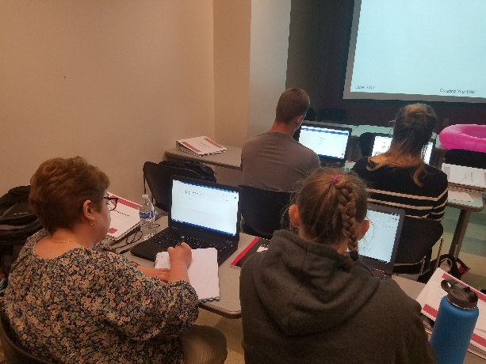
Figure 1: Denny Dubbs Introducing Wiki Figure 2: Starting First Page of Website
After introducing the material and explaining what a Wiki is, Denny Dubbs instructed the RET participants to log into their Google accounts. Denny Dubbs recommended doing all the work in Google Chrome Browser, as all the Google functions are synced to operate the best in its own browser. The RET participants then established a Home Page, see Figure 2, with their first and last name as their website domain in conjunction with Google Sites. Denny Dubbs explained that the firstname-initial-lastname-year format kept the site unique and easy to remember.
Next, Denny Dubbs walked through the process of establishing pages and organizing them on the Wikis. The RET participants were tasked with creating two pages: one for their unit (titled “Unit 1”) and one for their class or bell schedules (titled “Schedules & Plans”). Denny Dubbs went through the editing process as well, and no RET participants seemed to have any trouble following the material up to this point in the presentation. He wrapped up his portion of the talk by looking up three different examples of completed Wiki pages from RET participants of previous years.
For the next section of the material, Jack Broering took over. Similar to Denny Dubbs, he outlined the objectives of his section, which was on modifying one’s Wiki page. First, he had RET participants open the Wiki Workshop files that were downloaded prior to the presentation. Then, using the edit button on the Wiki page, walked through the process of inserting files. Hitting the insert tab, (see Figure 3), led to a number of options for the RET participants to follow. Jack Broering used stock photo examples to help the participants upload a photo to their main page. Many RET participants used their actual photos. Jack Broering explained that uploading files, attaching Youtube videos, and other additions were just as easy to attach to one’s Wiki pages.
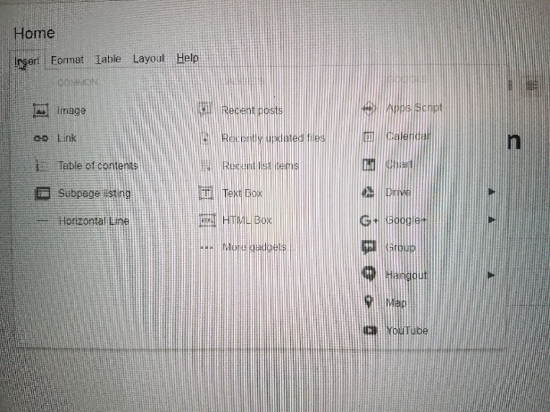
Figure 3: Reviewing Insert Options
Finally, Jack Broering finished the presentation by reviewing how to share and collaborate with the Wiki pages. It was recommended that all RET participants share their Wiki page with Denny Dupps, and that they make him an “owner” so that he can edit the work himself if there were technical problems. RET participants made sure to keep their website public so that their work could be recognized on the CEEMs website. By the time the presentation was over, most of the RET participants had shared their work with the presenters and began uploading and editing their page for the future of the program. In brief, the RET participants learned (1) the purpose and definition of a Wiki page (2) how to set up a Wiki page and how to edit it and (3) how to share their Wiki pages.

